Modeling Behavioral Interaction Features in AI-Driven Learning Systems
Iulia Georgiana Buhai
Ap

Acknowledgement
This work was supported by a KING CAROL I-st research fellowship granted by the National Research Authority, contract number 30382/09.02.2026.
Table of Contents
- Introduction
- Related Work
- Dataset and Methodology
3.1 Feature Engineering
3.2 Data
3.3 Experimental Setup
- Behavioral Model
4.1 Engagement (Interaction Intensity)
4.2 Persistence (Cognitive Effort)
4.3 Efficiency (Outcome Relative to Effort)
4.4 Friction Tolerance (Pure Effort)
- Results and Discussion
5.1 Behavioral Trends
5.2 Predictive Modeling of Continued Usage
5.3 Feature Importance Analysis
- Conclusion
- References

Introduction
AI is fundamentally reshaping education, yet its success hinges on how learners engage with tools rather than their availability. Understanding behavioral interaction patterns is, therefore, critical for evaluating both learning outcomes and long-term system adoption [1].
While prior research emphasizes performance metrics, it often overlooks behavioral features like engagement intensity, persistence, and efficiency. These signals offer deeper insight into how students balance effort, AI reliance, and perceived outcomes during study sessions [2].
This study investigates the role of behavioral metrics in predicting user satisfaction and continued usage. Using simulated study data, by constructing normalized indicators ( engagement, persistence, efficiency, and friction tolerance)to evaluate their specific impact on retention.
Results identify efficiency as the dominant predictor of continued usage, suggesting that users prioritize outcome quality over raw interaction volume. These findings provide a framework for designing more effective, user-centered AI learning systems.

Related work

Current learning analytics often rely on simple metrics like "time-on-task" to predict performance. However, these models frequently overlook complex dynamics like persistence under effort or dependence on AI assistance. This study addresses this gap by introducing a unified framework that integrates engagement, persistence, efficiency, and friction tolerance into a single predictive model.

Dataset and Methodology

Feature Engineering
To ensure comparability across variables with different scales, raw interaction features are standardized using Z-score normalization:
$$Z\left(x\right)=\frac{x-μ}{σ}$$
where $μ$ and $σ$ denote the mean and standard deviation of the feature, respectively.
Outcome-related variables are transformed using Min-Max scaling to map values to the interval [0,1]:
$$\text{MinMax}\left(x\right)=\frac{x-x_{min}}{x_{max}-x_{min}}$$
This ensures strictly positive values, which are required for ratio-based feature construction.
For stability in division operations, a small constant $ϵ=0.01$ is introduced to prevent division by zero. Additionally, the Engagement metric is shifted to ensure strictly positive values:
$${\text{Engagement}}_{\text{shifted}}=\text{Engagement}+\left|min\left(\text{Engagement}\right)\right|+ϵ$$
These transformations ensure numerical stability and prevent scale-related distortions in the computed behavioral metrics.

Data
The data represents a synthetic dataset that models student interaction with AI-assisted learning systems. The dataset contains 11 fields with data collected during AI-assisted study sessions. The dataset used in this study was obtained from Kaggle [4] . Before any analysis was done, the data was cleaned(unnecessary fields were removed, non-numerical fields were replaced with numerical representations), behavioral features were computed(Engagement, Persistence, Efficiency, and Friction tolerance), and each feature was constructed to positively or negatively weight behavioral signals [3].

Experimental Setup

A Random Forest classifier was trained to predict continued usage (binary return status) using an 80/20 stratified split. Optimized via randomized hyperparameter search and cross-validation, the final model utilized 100 trees (max depth 10, Gini impurity) and a fixed random seed for reproducibility. Performance was assessed using accuracy, ROC AUC, precision, and recall to account for class imbalance. The full preprocessing and training pipeline is documented in the accompanying Kaggle notebook.

Behavioral Model
The behavioral dimensions considered in this study are conceptually grounded in prior work on the ThinkR platform [6], where interaction-based features were shown to reflect cognitive and motivational aspects of learning behavior .

Engagement (Interaction Intensity)
Engagement captures the total volume of interaction, balancing both time spent and prompt frequency. The engagement feature is rewarding each prompt and each minute spent studying. The formula of engagement is the following:
$$\text{Engagement}=Z\left(\text{TotalPrompts}\right)+Z\left(\text{SessionLengthMin}\right)$$

Persistence (Cognitive Effort)
Persistence measures sustained effort; it gently penalizes over-reliance on AI assistance (which requires less independent cognitive effort)and rewards the cognitive effort. The coefficient (0.3) was empirically chosen to moderate the influence of AI assistance, ensuring that assistance moderates but does not dominate the persistence signal. This reflects the assumption that moderate AI use supports learning, while excessive reliance reduces independent cognitive effort. The formula of persistence is the following:
$$\text{Persistence}=Z\left(\text{TotalPrompts}\right)-\left(0.3×Z\left(\text{AI_AssistanceLevel}\right)\right)$$

Efficiency (Outcome Relative to Effort)
Efficiency computes the successful output relative to engagement; it is modeled as outcome quality relative to interaction cost. The formula of efficiency is the following:
$$\text{Efficiency}=\frac{MinMax\left(\text{FinalOutcome}\right)×MinMax\left(\text{SatisfactionRating}\right)}{{\text{Engagement}}_{\text{shifted}}+ϵ}$$

Friction Tolerance (pure effort)
The Friction Tolerance metric captures cognitive effort by penalizing reliance on AI assistance. Higher values indicate users who engage actively while maintaining lower dependence on automated support. While less expressive than composite features, it serves as a baseline indicator of autonomy in interaction behavior. The formula of friction tolerance is the following:
$$\text{FrictionTolerance}=\text{TotalPrompts}-\text{AI_AssistanceLevel}$$
Together, these metrics form a structured behavioral representation of user interaction, balancing effort, outcome, and assistance. This feature space enables the subsequent analysis of their relative importance in predicting satisfaction and continued usage.

Results and Discussion
Following the extraction and normalization of behavioral features, their relationships with learning outcomes, user satisfaction, and continued usage were analyzed. Both exploratory analysis and predictive modeling were employed to identify the most influential behavioral signals.

Behavioral Trends
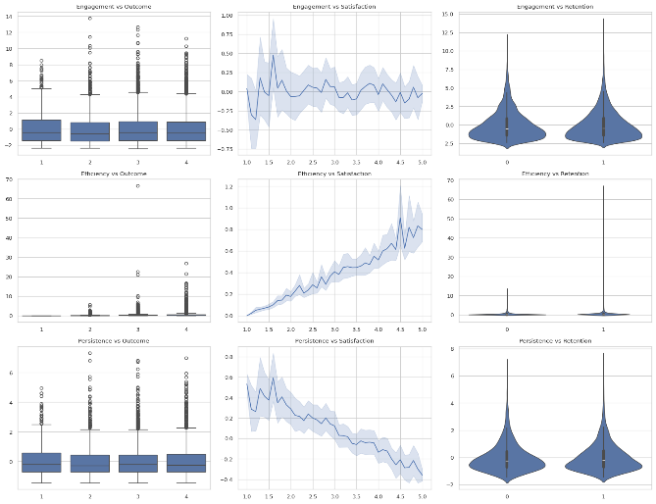
    - Engagement.
Engagement exhibits a strong positive relationship with both learning outcomes and user satisfaction. Higher engagement scores, derived from increased interaction frequency and session duration, consistently correspond to improved outcomes. This trend suggests that active and sustained interaction with AI-assisted systems contributes positively to task completion and perceived effectiveness. The presence of outliers, captured through Z-score normalization, reflects meaningful behavioral variation rather than noise, indicating distinct user interaction patterns.
Figure 1Behavioral feature relationships across outcome, satisfaction, and retention dimensions. Rows represent behavioral metrics (Engagement, Efficiency, Persistence), and columns correspond to Final Outcome, Satisfaction Rating, and Continued Usage.
    - Persistence.
Persistence demonstrates a clear positive association with successful task completion. Users who achieve higher outcomes tend to exhibit higher persistence scores, reflecting sustained effort and continued interaction. However, an inverse relationship is observed between persistence and satisfaction. Users reporting the highest satisfaction levels tend to require less persistence, suggesting that prolonged effort may be associated with friction or difficulty during interaction. This highlights a trade-off between effort and user experience: persistence supports success, but excessive persistence may reduce perceived usability.
    - Efficiency.
Efficiency presents the most distinctive behavioral pattern. While lower and intermediate outcome categories show relatively low and stable efficiency values, a sharp increase is observed for sessions resulting in successful task completion. Similarly, higher satisfaction levels strongly correlate with increased efficiency. This indicates that users derive the greatest satisfaction when achieving high-quality outcomes with minimal interaction cost. Efficiency captures the balance between effort and outcome, making it a critical indicator of effective system use.

Predictive Modeling of Continued Usage
The optimized model achieved an accuracy of 72.5% and an ROC AUC score of 0.65, indicating moderate predictive capability. While overall performance is satisfactory, class-level analysis reveals an imbalance in predictive sensitivity. The model achieved a recall of 0.25 for non-returning users, indicating limited detection of disengagement cases. However, precision for this class reached 0.57, suggesting that flagged at-risk users are identified with relatively high reliability.

Feature Importance Analysis
Feature importance analysis derived from the trained Random Forest model highlights the relative contribution of each behavioral metric:
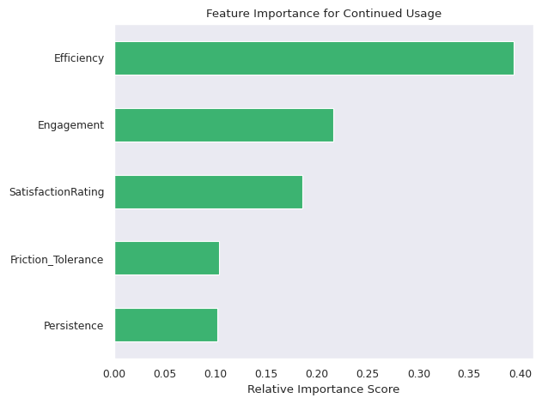
- Efficiency is the dominant predictor, contributing approximately 40% of the model’s decision weight.
Figure 2. Feature importance scores derived from the trained Random Forest model. The plot shows the relative contribution of behavioral metrics, Engagement, Persistence, Efficiency, Friction Tolerance, and Satisfaction Rating in predicting continued usage
- Engagement (22%) and Satisfaction Rating (18%) serve as strong secondary predictors.
- Persistence and Friction Tolerance contribute the least (approximately 10% each).
These results indicate that continued usage is primarily driven by the efficiency of interaction rather than raw effort. Users are significantly more likely to return when their interactions yield high-quality outcomes relative to the time and effort invested.

Conclusion
This study proposed a structured framework for modeling behavioral interaction features in AI-assisted learning systems and evaluated their relationship with user satisfaction and continued usage.
The results indicate that behavioral efficiency is the most significant predictor of system retention, outperforming both engagement and effort-based metrics. This suggests that users prioritize achieving high-quality outcomes with minimal interaction cost rather than maximizing interaction intensity. Accordingly, efficiency emerges as a unifying behavioral signal that captures both performance effectiveness and perceived user experience.
These findings have direct implications for the design of AI-driven educational systems. In particular, systems should prioritize optimizing outcome efficiency and reducing unnecessary interaction overhead, rather than focusing solely on increasing engagement or interaction volume. Such design choices are more likely to support sustained user adoption and perceived usability.
This study is limited by its use of synthetic data, predefined feature assumptions, and a single-dataset evaluation, which may affect real-world generalizability. However, the proposed framework offers a robust model for behavioral analysis. Future work should validate these findings with real-world datasets and investigate temporal behavior over longer learning periods.
References
- G. Siemens and R. S. Baker, “Learning analytics: Envisioning a research discipline and a domain of practice,” Proceedings of the 2nd International Conference on Learning Analytics and Knowledge, 2012.
- J. A. Fredricks, P. C. Blumenfeld, and A. H. Paris, “School engagement: Potential of the concept, state of the evidence,” Review of Educational Research, vol. 74, no. 1, pp. 59–109, 2004.
- R. S. Baker and P. S. Inventado, “Educational data mining and learning analytics,” pp. 61–75, 2014.
- A. Saleem, “Ai assistant usage in student life,” https://www.kaggle.com/datasets/ayeshasal89/ ai-assistant-usage-in-student-life-synthetic, 2026, accessed: 2026-02-25.
- L. Breiman, “Random forests,” Machine Learning, vol. 45, no. 1, pp. 5–32, 2001.
- B. I. Georgiana, “Learning behavior analysis using digital tools,” Penrose Magazine, vol. 6, no. Issue 6: Neuroscience Mini Issue, pp. 11–14, 2026.

